**Kidus Tilahun**

**CMSC 203**

UML

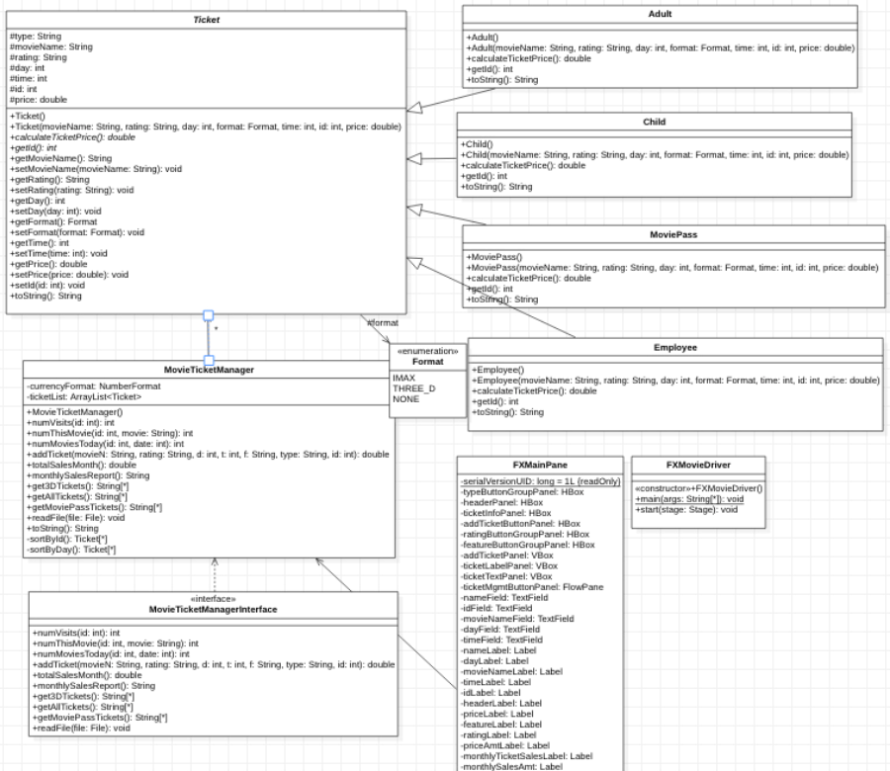

Screenshots

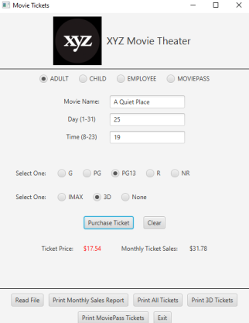

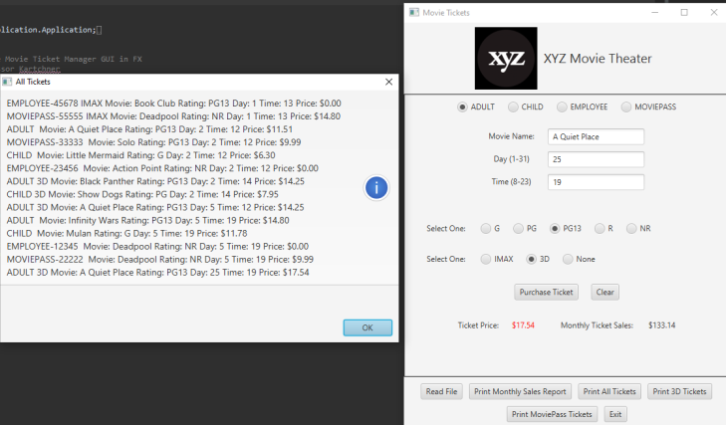

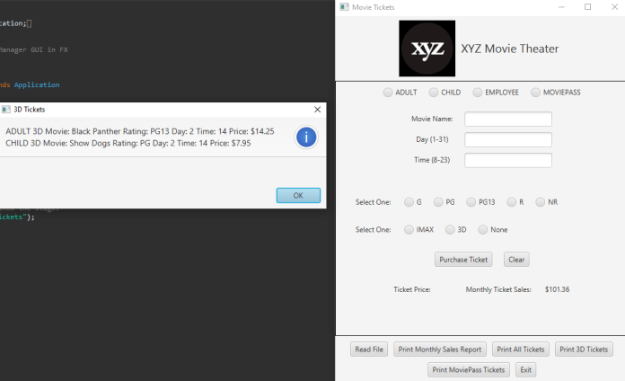

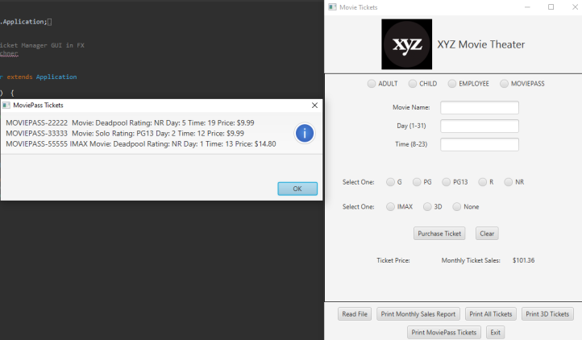

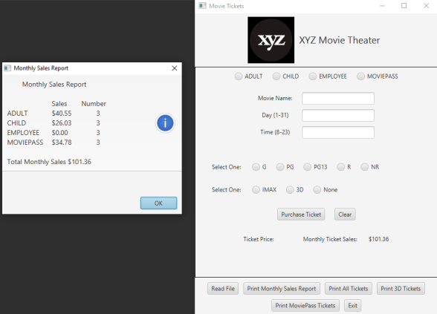

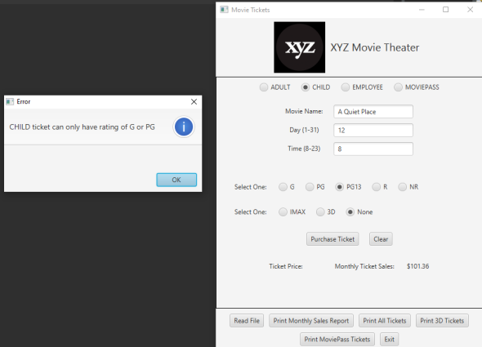

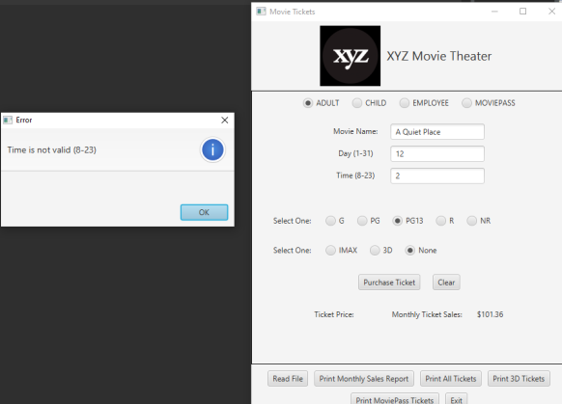

**Lesson Learned**

For a last project this was reasonably challenging but I enjoyed it. Although it challenged me I eventually figured out to display the xyz image. But The hardest and most challenging part was to think the logic behind the different Ticket child’s. My original plan was to set the price inside the constructor using the calculate Price method, calling the constructor when using the add Ticket method. am glad it finally worked.